PROJECT REPORT

**ON**

**BANK MANAGEMENT SYSTEM**

Institute of Engineering & Applications



**Submitted by**

**Name of student: Anurag Singh**

**Roll no.:** 201500128

**Name of student: Shreya Patel**

**Roll no.:** 201500672

**Name of student: Kritika Pathak**

**Roll no.:** 201500354

**Department of Computer Engineering &Application**

**Institute of Engineering & Technology**

**GLA University Mathura- 281406, INDIA**

**Declaration**

We hereby declare that work which is being presented in the project report “**Bank Management System”**,in partial fulfillment of the requirements for project is an authentic record of my own work carried under the supervision of **_____________________, Assistant Professor,GLA University,Mathura.**

**Sign___________________**

**Name of student: Anurag Singh**

**Roll no.:** 201500128

**Sign___________________**

**Name of student: Shreya Patel**

**Roll no.:** 201500672

**Sign___________________**

**Name of student: Kritika Pathak**

**Roll no.:** 201500654

**Sign___________________**

**Certificate**

This is to certify that the above statements made by the candidate are correct to the best of our knowledge and belief.

_____________________

**Project Supervisor**

**________________________**

Assistant Professor,

GLA University,

Mathura.

**TABLE OF CONTENTS**

|  |  |
| --- | --- |
| **S.No** | **Index** |
| **1.** | **Certificate** |
| **2.** | **Introduction**  **2.1 (Objective)**  **2.2 (Overview)** |
| **3.** | **Project Training Design**  **3.1 (System Requirement)** |
| **4.** | **Project Implementation** |
| **5.** | **Implementation & User Interface** |

**Introduction**

**2.1 Objective Of The Project:**

* To design a program of Bank Management System using Python.
* To perform banking functions like –
* Open new account
* Withdraw and Deposit money
* Check balance of client’s account
* To make banking system easy for client.

**2.2 Overview Of The Project:**

Bank Management System project is written in Python. The project file contains a python script (main.py) and a database file. This is a simple console based system which is very easy to understand and use. Talking about the system, it contains all the basic functions which include creating a new account, view account holders record, withdraws and deposit amount, balance inquiry and a security pin generation . In this mini project, there is a secure login system. This means he/she can use all those available features easily by entering a security pin (for safety purpose). It is too easy to use, he/she can check the total bank account records easily.

**Project Training Design**

**3.1 System Requirement:**

* Operating System: OSx
* Frontend : Python programming
* Backend: Python programming
* IDE: IntelliJ IDEA

**Project Implementation**

NamesOFClients = ['Ankit', 'Rahul', 'Priya', 'Aviral', 'Saurabh', 'Vishal', 'Kun']

ClientPins = ['0001', '0002', '0003', '0004', '0005', '0006', '0007']

ClientBalances = [10000, 20000, 30000, 40000, 50000, 60000, 70000]

ClientDeposition = 0

ClientWithdrawal = 0

ClientBalance = 0

disk1 = 1

disk2 = 7

u = 0

while True:

# os.system("cls")

print("************************************************************")

print("========== WELCOME TO BANKING SYSTEM ==========")

print("************************************************************")

print("========== (a). Open New Client Account ============")

print("========== (b). The Client Withdraw a Money ============")

print("========== (c). The Client Deposit a Money ============")

print("========== (d). Check Clients & Balance ============")

print("========== (e). Quit ============")

print("************************************************************")

**Project Implementation**

EnterLetter = input("Select a Letter from the Above Box menu : ")

if EnterLetter == "a":

print(" Letter a is Selected by the Client")

NumberOfClient = eval(input("Number of Clients : "))

u = u + NumberOfClient

if u > 7:

print("\n")

print("Client registration exceed reached or Client registration too low")

u = u - NumberOfClient

else:

while disk1 <= u:

name = input("Write Your Fullname : ")

NamesOFClients.append(name)

pin = str(input("Please Write a Pin to Secure your Account : "))

ClientPins.append(pin)

ClientBalance = 0

ClientDeposition = eval(input("Please Insert a Money to Deposit to Start an Account : "))

ClientBalance = ClientBalance + ClientDeposition

ClientBalances.append(ClientBalance)

print("\nName=", end=" ")

**Project Implementation**

print(NamesOFClients[disk2])

print("Pin=", end=" ")

print(ClientPins[disk2])

print("Balance=", "P", end=" ")

print(ClientBalances[disk2], end=" ")

disk1 = disk1 + 1

disk2 = disk2 + 1

print("\nYour name is added to Client Table")

print("Your pin is added to Client Table")

print("Your balance is added to Client Table")

print("----New Client account created successfully !----")

print("\n")

print("Your Name is Available on the Client list now : ")

print(NamesOFClients)

print("\n")

print("Note! Please remember the Name and Pin")

print("========================================")

mainMenu = input(" Press Enter Key to go Back to Main Menu to Conduct Another Transaction or Quit_")

elif EnterLetter == "b":

v = 0

print(" letter b is Selected by the Client")

**Project Implementation**

while v < 1:

w = -1

name = input("Please Insert a name : ")

pin = input("Please Insert a pin : ")

while w < len(NamesOFClients) - 1:

w = w + 1

if name == NamesOFClients[w]:

if pin == ClientPins[w]:

v = v + 1

print("Your Current Balance:", "P", end=" ")

print(ClientBalances[w], end=" ")

print("\n")

ClientBalance = (ClientBalances[w])

ClientWithdrawal = eval(input("Insert value to Withdraw : "))

if ClientWithdrawal > ClientBalance:

deposition = eval(input(

"Please Deposit a higher Value because your Balance mentioned above is not enough : "))

ClientBalance = ClientBalance + deposition

print("Your Current Balance:", "P", end=" ")

print(ClientBalance, end=" ")

ClientBalance = ClientBalance - ClientWithdrawal

**Project Implementation**

print("-\n")

print("----Withdraw Successfully!----")

ClientBalances[w] = ClientBalance

print("Your New Balance: ", "P", ClientBalance, end=" ")

print("\n\n")

else:

ClientBalance = ClientBalance - ClientWithdrawal

print("\n")

print("----Withdraw Successfully!----")

ClientBalances[w] = ClientBalance

print("Your New Balance: ", "P", ClientBalance, end=" ")

print("\n")

if v < 1:

print("Your name and pin does not match!\n")

break

mainMenu = input(" Press Enter Key to go Back to Main Menu to Conduct Another Transaction or Quit_")

elif EnterLetter == "c":

print("Letter c is selected by the Client")

x = 0

while x < 1:

w = -1

**Project Implementation**

name = input("Please Insert a name : ")

pin = input("Please Insert a pin : ")

while w < len(NamesOFClients) - 1:

w = w + 1

if name == NamesOFClients[w]:

if pin == ClientPins[w]:

x = x + 1

print("Your Current Balance: ", "P", end=" ")

print(ClientBalances[w], end=" ")

ClientBalance = (ClientBalances[w])

print("\n")

ClientDeposition = eval(input("Enter the value you want to deposit : "))

ClientBalance = ClientBalance + ClientDeposition

ClientBalances[w] = ClientBalance

print("\n")

print("----Deposition successful!----")

print("Your New Balance: ", "P", ClientBalance, end=" ")

print("\n")

if x < 1:

print("Your name and pin does not match!\n")

break

**Project Implementation**

mainMenu = input(" Press Enter Key to go Back to Main Menu to Conduct Another Transaction or Quit_")

elif EnterLetter == "d":

print("Letter d is selected by the Client")

w = 0

print("Client name list and balances mentioned below : ")

print("\n")

while w <= len(NamesOFClients) - 1:

print("->.Customer =", NamesOFClients[w])

print("->.Balance =", "P", ClientBalances[w], end=" ")

print("\n")

w = w + 1

mainMenu = input(" Press Enter Key to go Back to Main Menu to Conduct Another Transaction or Quit_ ")

elif EnterLetter == "e":

print("letter e is selected by the client")

print("Thank you for using our banking system!")

print("\n")

print("Thank You and Come again")

print("God Bless")

break

else:

**Project Implementation**

print("Invalid option selected by the Client")

print("Please Try again!")

mainMenu = input("Press Enter Key to go Back to Main Menu to Conduct Another Transaction or Quit_")

**OUTPUT**

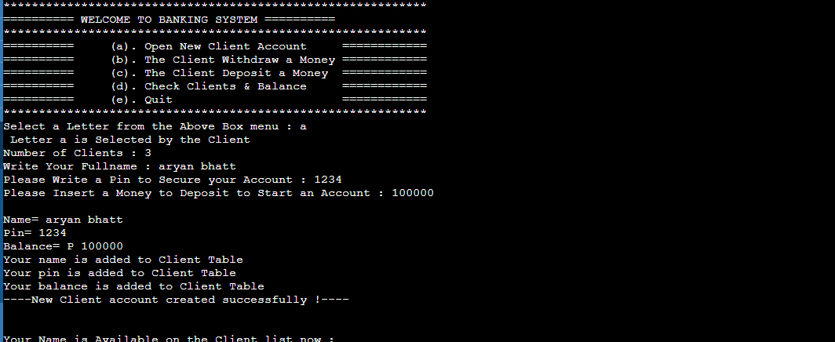

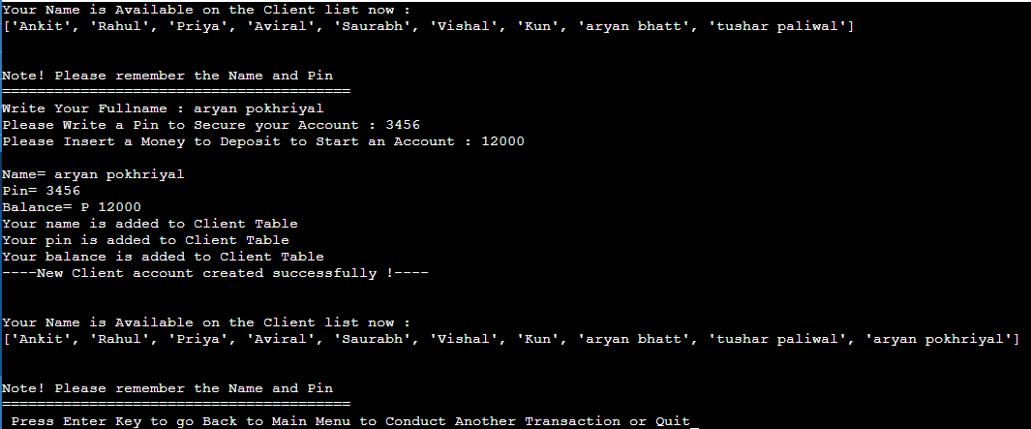

**OUTPUT**

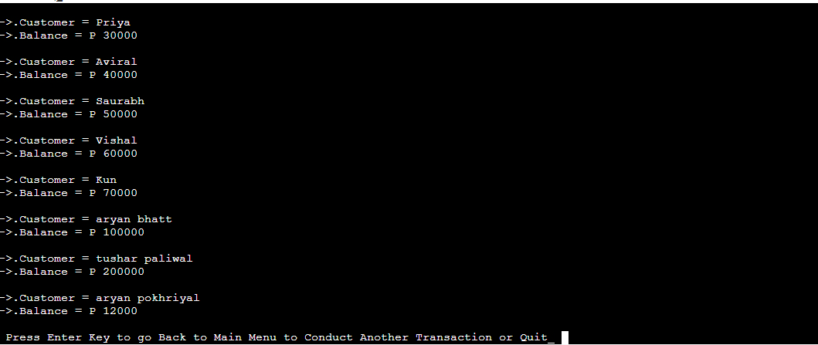

**References**

* Some courses books – for system / use case diagrams.
* Google.com – for acquiring data about the project.
* Tutorialspoint.com – to gather some knowledge for sources code.
* IntelliJ IDEA– to run the sources code.